Maudsley Hospital – Physiotherapy Department

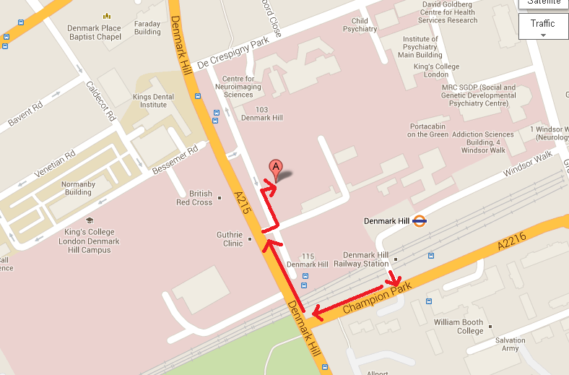

The hospital is a short distance from Denmark Hill train station. There is also the 185 bus from Vauxhall which stops out the hospital as well as many other buses that run from Elephant & Castle or Waterloo.

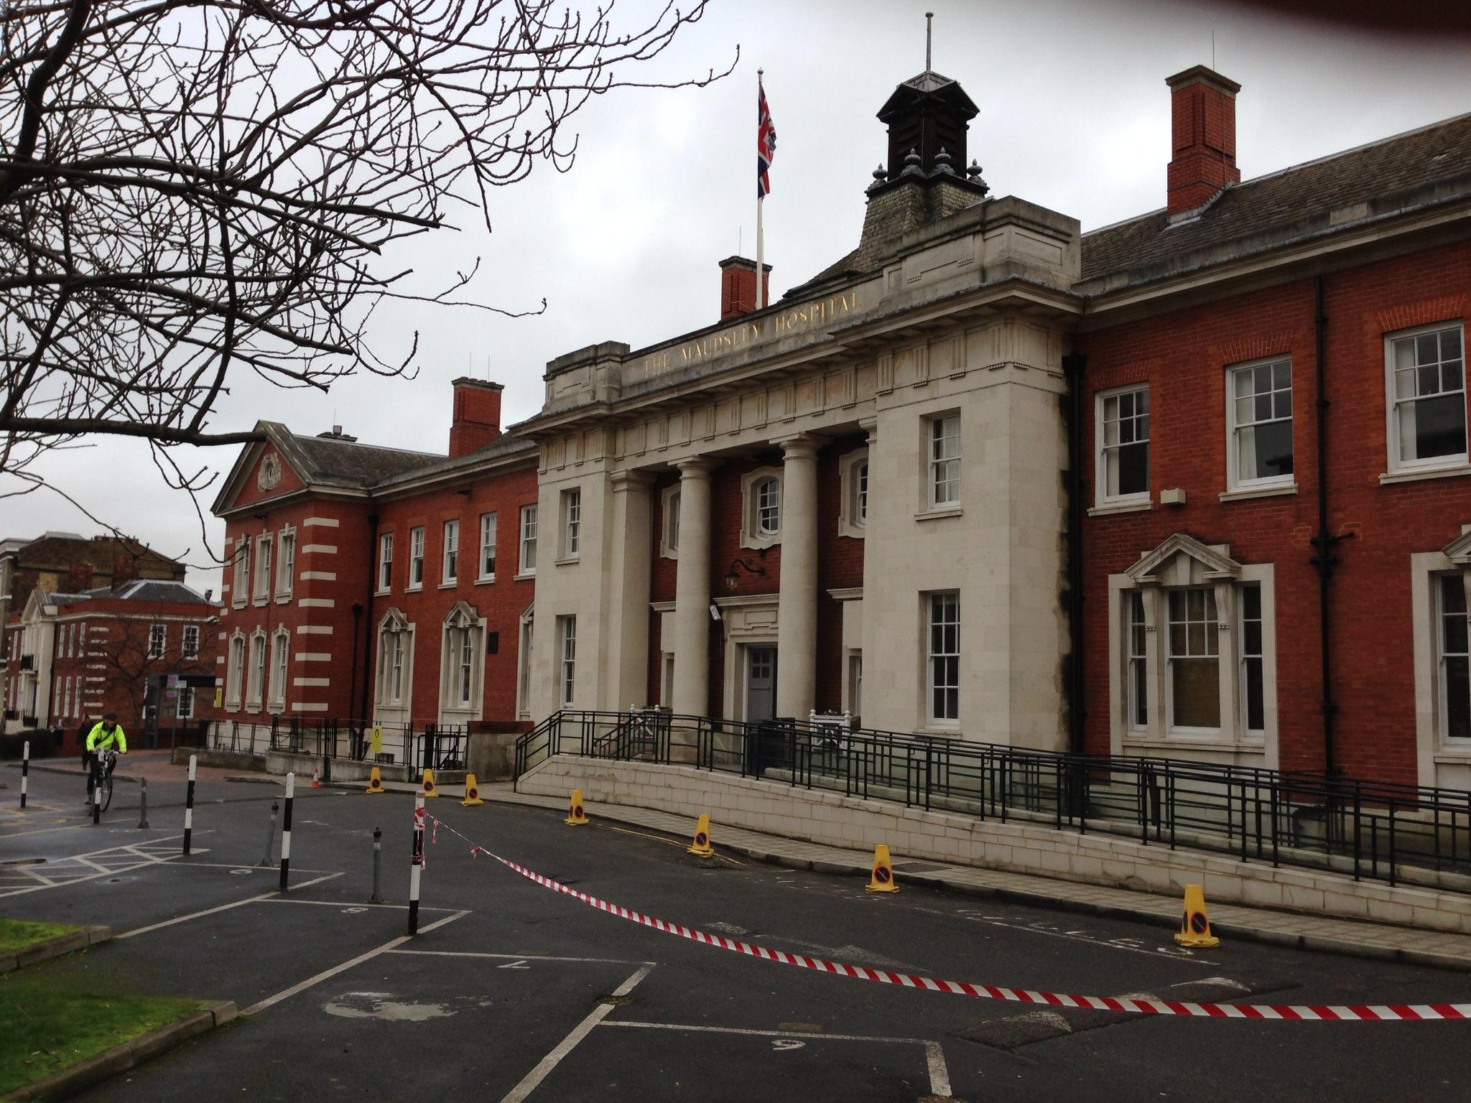

Enter through the main entrance, left through the double doors, and we are the second door on your left. There is a large red post box next to the front door, buzz the intercom and you will be let in.



